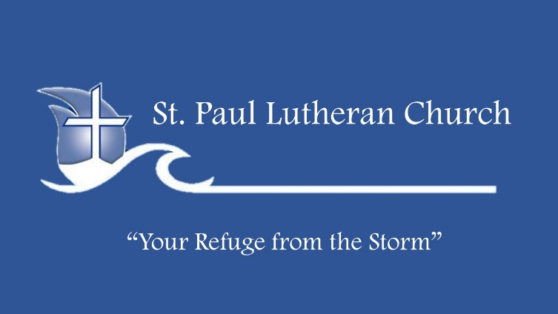
Life Group Bible Study
Let Freedom…Love
July 3, 2022

This week: Read the following passage slowly, making note of any words or phrases that stand out to you.

Matthew 27:50-54 NLT Then Jesus shouted out again, and He released His spirit. 51 At that moment the curtain in the sanctuary of the Temple was torn in two, from top to bottom. The earth shook, rocks split apart, 52 and tombs opened. The bodies of many godly men and women who had died were raised from the dead. 53 They left the cemetery after Jesus' resurrection, went into the holy city of Jerusalem, and appeared to many people. 54 The Roman officer and the other soldiers at the crucifixion were terrified by the earthquake and all that had happened. They said, "This man truly was the Son of God!"

Getting Started:
1. If someone was to ask you about freedom in Christ, what would you say?

2. What are some examples of gaining freedom in your own life?

Read Galatians 5:1-15: Read slowly, making note of words or phrases that stand out and write down anything that’s confusing or any questions that come to mind.

Galatians 5:1-15 NLT So Christ has truly set us free. Now make sure that you stay free, and don't get tied up again in slavery to the law. 2 Listen! I, Paul, tell you this: If you are counting on circumcision to make you right with God, then Christ will be of no benefit to you. 3 I'll say it again. If you are trying to find favor with God by being circumcised, you must obey every regulation in the whole law of Moses. 4 For if you are trying to make yourselves right with God by keeping the law, you have been cut off from Christ! You have fallen away from God's grace. 5 But we who live by the Spirit eagerly wait to receive by faith the righteousness God has promised to us. 6 For when we place our faith in Christ Jesus, there is no benefit in being circumcised or being uncircumcised. What is important is faith expressing itself in love. 7 You were running the race so well. Who has held you back from following the truth? 8 It certainly isn't God, for He is the One who called you to freedom. 9 This false teaching is like a little yeast that spreads through the whole batch of dough! 10 I am trusting the Lord to keep you from believing false teachings. God will judge that person, whoever he is, who has been confusing you. 11 Dear brothers and sisters, if I were still preaching that you must be circumcised—as some say I do—why am I still being persecuted? If I were no longer preaching salvation through the cross of Christ, no one would be offended. 12 I just wish that those troublemakers who want to mutilate you by circumcision would mutilate themselves. 13 For you have been called to live in freedom, my brothers and sisters. But don't use your freedom to satisfy your sinful nature. Instead, use your freedom to serve one another in love. 14 For the whole law can be summed up in this one command: "Love your neighbor as yourself." 15 But if you are always biting and devouring one another, watch out! Beware of destroying one another.

1. If a friend asked you about this scripture, how would you explain these verses in two sentences?

2. What does it look like to have freedom in your life? How have you served your neighbors?

3. What do you think Paul is meaning when he wrote, “if you accept circumcision, Christ will be of no advantage to you”? What does Paul mean by this?

4. What would it look like for you to live a life that reflected the verse, “For in Christ Jesus neither circumcision nor uncircumcision counts for anything, but only faith working through love”? How have you been loving those around you? How is your faith at work in your everyday interactions with the people around you?

5. What is Paul warning us about in the last couple of verses? How have you seen freedom taken as an opportunity for the flesh? How have you used freedom for that opportunity? How can we work together as kingdom workers to fulfill the message of the Gospel? How can you support your brothers and sisters around you in the message of faith working through love?

Walking With Jesus
Something that is often forgotten in the disciplines is that of celebration. This discipline is typically one of the most difficult disciplines for people to learn. It feels different than most of the other disciplines. In this discipline we reflect on our successes and failures of previous disciplines. We celebrate walking as one in Christ. We celebrate another week of opportunities to love the least.
In Adele Ahlberg Calhoun’s book Spiritual Disciplines Handbook, she writes:

The world is filled with reasons to be downcast. But deeper than sorrow thrums the unbroken pulse of God’s joy, a joy that will yet have its eternal day. To set our hearts on this joy reminds us that we can choose how we respond to any particular moment. We can search for God in all circumstances, or not. We can seek the pulse of hope and celebration because it is God’s reality. Heaven is celebrating. Right now cherubim, seraphim, angels, archangels, prophets, apostles, martyrs and all the company of saints overflow with joy in the presence of their Creator. Every small experience of Jesus with us is a taste of the joy that is to come. We are not alone and that in itself is reason to celebrate.

Take some time this month to celebrate with the people who bring joy to your life. Celebrate with community and fellowship. Share with each other what is going on in your lives. Be there for the hard times and the great times. It is also useful for you to go to the place where you feel like you and God connect best. Find a quiet place in the woods, by the water or a comfy chair in your house and just spend time thanking Him for all that He has done. Continue to be in prayer that He could bring you abundantly more things to celebrate.

