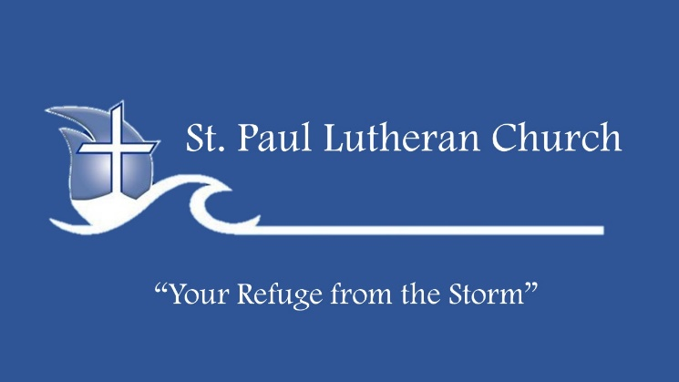
Life Group Bible Study

SUPERNATURAL – Holy Spirit

JULY 7, 2022

KEY POINTS:
The Holy Spirit gives you the power to:
• be saved
• make the right decisions
• live a holy life
• share Christ boldly
• Make a difference with spiritual gifts

ICE BREAKERS:
• The trinity is the Father, Son and Holy Spirit. What (if any) ideas did you have growing up about the Holy Spirit?
• What do you think it means to live a supernatural life?

CONNECTING:
1. What was the Holy Spirit’s role in bringing you to Christ? (see John 3:3-7) When does a person receive the gift of the Holy Spirit? (see Eph 1: 13) How often do you think about the fact that your body is the temple of the Holy Spirit? Is it possible to be saved without having the Holy Spirit? (see Rom 8:9)

2. Why is it important that we acknowledge and depend on the Holy Spirit in our daily life? What does the Holy Spirit do for us, for which we often take the credit? (see John 14:26 and 16:13) What does the Holy Spirit produce in us, as we walk in dependence on Him? (see Gal 5: 22-23) How does this make a difference in our behavior, emotions, and relationships?

3. How do you recognize the leading of the Holy Spirit in your life? Paul instructs us in Gal 5:25 to walk by the Spirit. In practical terms, what does this mean? How do we, personally, benefit by being filled, led and empowered by the Holy Spirit? In what specific ways have you experienced the Holy Spirit empowering you to live a holy life?

4. Read Eph. 4:30-32. Describe a time you believe you resisted or grieved the Holy Spirit. How have you tried to live a holy life in your own power and what was the result? What role does surrender play in being filled with the Holy Spirit? What areas of your life do you need to surrender to the Holy Spirit’s control?

5. Read Rom. 12:6-8 and 1 Cor. 12:27-31. The Holy Spirit gives each of us gifts to minister. Describe two of your spiritual gifts. How are you using them to make a difference?

WALKING WITH JESUS:
1. Get to know the person of the Holy Spirit better by studying the verses listed below. Write a thank you note to the Holy Spirit, acknowledging the many ways He has enriched your life and made a difference in and through you. Start each day by acknowledging His presence and asking Him to fill you and lead you, moment by moment, as you surrender your life to Him.

2. Ask the Holy Spirit to show you anything that would prevent Him from filling you. (This might include things such as: unconfessed sins, unbelief, bitterness, and areas of rebellion, pride, self-reliance, or putting other people/things before God.) Humbly agree with God concerning these hindrances and express to Him your desire to be filled with the Spirit, so that your life brings glory to Him.

DISCOVERY QUESTIONS:
Read John 7:37-39.
To what kind of thirst was Jesus referring? In what ways have you tried to satisfy your thirst apart from Christ? What did Jesus promise those who believe in Him? (7:38) What word picture does Jesus use to describe being filled with the Spirit? (7:37) What do you think this means? How do others benefit from the Spirit flowing out of us? Are you currently experiencing the Spirit like a river, a stream, or a trickle?

Read John 14:16-24; 15:26-27; 16:13-15.
What names does Jesus use to describe the Holy Spirit? List the different things Jesus promises that the Holy Spirit will do for us. Reflect on how you have experienced the Holy Spirit doing these things for you. How often do you credit Him with your spiritual growth?

Read Ephesians 5:8-10, 15-21
What is God’s will concerning our spiritual walk? What are the characteristics of those “walking in the light”? How are we to make the most of our time? To be filled means to be motivated, stimulated, empowered and influenced by something (example: a person filled with anger) Do you think it is possible to please God without being filled with the Spirit? Why do you think Paul contrasts being filled with the Spirit and being intoxicated? How does the Holy Spirit desire to impact our thought life? Our relationships? What indications do you see in your life that you are filled with the Spirit?

VERSES FOR FURTHER STUDY:
John 3:5-6, 6:63, 16:7, 13-14; Acts 2:38-39, 4:8-13, 31, 7:51; Rom 5:5, 7:6, 8:1-17, 26-27, 12::5-8, 15:23 1 Cor 2:4-5, 10-16, 6:19-20, 12:7-13; Gal 5:16-18, 22-25; Eph 3:14-21, 4:30, Phil 4:13; Heb 2:4; James 4:5

