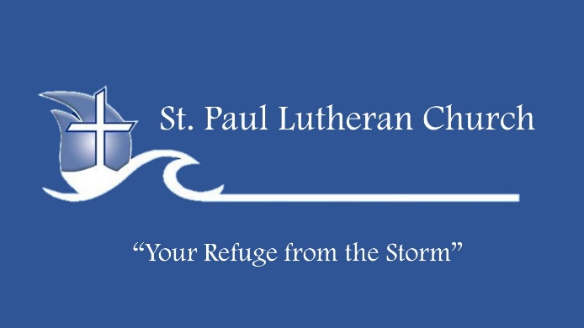
Life Group Bible Study

SUPERNATURAL – Angels

August 21, 2022

KEY POINTS:
1. Who are angels?
• Angels are worshippers
• Angels are warriors
• Angels are messengers
2. What do angels do?
• Give you direction
• Protect you from danger
• Minister to you

ICE BREAKER:
• As a child, what did you believe about angels?

CONNECTING:
1. How has your understanding of angels changed? In this series, “Supernatural”, we’ve examined spiritual warfare, the role of the Holy Spirit, demons and angels. What is the most significant thing God has shown you? How is this making a difference in your daily life?

2. Have you ever encountered an angel? If so, when? Share a time when you believe God (or one of His angels) divinely protected you? How should the knowledge that God sends His angels to protect us affect our life?

3. Like us, angels are created beings. In what other ways are we alike and in what ways are we different from angels? What can we learn from the angels’ examples? What do you think is meant by “we will judge angels”? (1 Cor 6:3)

4. Since angels sometimes appear in human form, we are to be hospitable to strangers. (Heb 13:2) Share a time when you think a stranger might have been an angel sent by God to minister to you. Also, angels can give us directions from God; through a vision, a dream or an audible voice (Gen 21:17, 28:12, Matt 1:20, 2:13,19; Acts 10:3). Have you ever seen an angel in a dream or vision or heard one’s voice?

5. The Bible instructs us not to worship angels (Col. 2:18; Rev 22:8-9). How do we guard against this? Is it okay to ask God to put His angels around us, for protection? If we don’t ask for this, does that mean we aren’t protected? Do you know of any examples in the Bible where believers prayed for angelic protection or direction? Would you like to have an encounter with an angel? Why or why not?

WALKING WITH JESUS:
1. In what situations do you become fearful and need to remember that God has His angels protecting you? Ask the Lord to make you more mindful of the fact that his angels are real and are here to direct, protect and minister to you. Memorize Ps 91:11-12. For He will order His angels to protect you wherever you go. They will hold you up with their hands so you won't even hurt your foot on a stone.

2. We need to realize that there is more going on than our natural eyes can see. Investigate God’s Word regarding angels in the affairs of mankind. Ask the Lord to enable you to comprehend and become more aware of the invisible, eternal realm. Regularly express gratitude to God for the presence of His angels, protecting, directing and ministering to you and those you love.

DISCOVERY QUESTIONS:
Learn more about angels by looking up the verses and filling in the blank.

Angels are mentioned in the Bible more than 250 times. Angel means messenger and they were created by _______ (Ps 148:2,5; Col 1:16). Angels are not physical but _______ beings (Heb 1:14). They often take the appearance of _______ (Mark 16:5-6, Luke 24:4). When people see angels they feel __________ (Luke 1:11-12, 2:9) so angels must tell them, “_______” (Luke 1:13, 30, 2:10). Angels minister in many supernatural ways (see Dan 6:22, 8:15-19, 9:21-23; Acts 7:35, 12:7-8, 11). They sometimes show up in our ______ (Matt 1:20) or in a ______(Acts 10:3). There are _________ angels in heaven (Heb 12:22; Rev 5:11). Angels can even be seen by ________(Num 22:25-27). ________ are assigned angels (Matt 18:10). They do not _______ or ______ (Luke 20:33-36;). Angels announce _______ (Rev 14:6-7) and inflict _______(Gen 19:12-13; Rev 15:1) We are not to _______ angels (Col 2:18; Rev 22:8-9). Angels are at war with _________ (Rev 12:7). Sometimes they ride ________ (2 Kings 6:17) Only three angels are mentioned by name: ___________ (Luke1:19) who acts as God’s _________(Luke 1:26); _________ (Dan10:13,21) who is always mentioned in the context of _______ (Rev 12:7); and Lucifer ( Isa 14:12 KJV) who was once a beautiful _______ (Ezk 28:12-17) before he fell from _____ to _____ (Isa 14:12). Three types of angels are mentioned in scripture: _________(Isa 6:2) which continually _________(Rev 4:8-9); ___________(Heb 9:5) who guarded the _________ (Gen 3:24) and covered the _________ (Ex 25:18-22); _________ (Jude 1:9) which may refer to their rank. The words translated principalities in Rom 8:38 and rulers in Col 1:16 begins with the prefix “arche,” suggesting archangel.

VERSES FOR FURTHER STUDY:
Gen 18:1ff, 19:1-22, 22:15; Num 22:21-35; Ps 34:7,103:20,148:1-2; Isa 6:3; Dan 4:13-17; Matt 1:18-24, 2:13, 4:5,13, 28:1-6; Luke 1:26-38, 2:8-15, 24:1-9; John 20:11-13; Acts 1:10-11, 8:26; 1Thess 4:16; 2 Thess 1:7; Heb 1:4-5, 2:9,14,13:2; 1 Pet 1:12; Rev 7:1, 8:2,19:10

