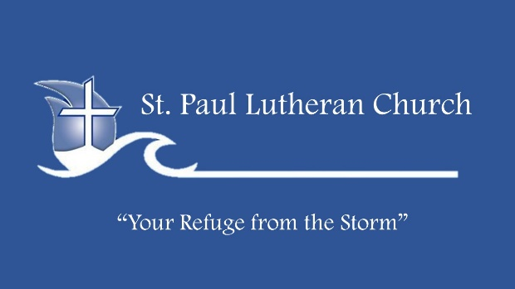
Life Group Bible Study
Christ The King
November 20, 2022

WELCOME
OPENING
Have you ever had one of those experiences in a restaurant where the menu was bigger than the phone book of most small towns? You sit down for a relaxing meal and encounter a sixteen, full-color, glossy-page collection of choices that make your head spin and your stomach growl. There is method to the madness: just lifting the menu will be a workout inspiring quite an appetite.

We live in a world of choices—every day we make hundreds based on what we know and believe to be right and good. In all of that there is an undercurrent of truth that informs how we live, and how we interact with others. There are times, though, like Pilate in today’s text, when we need to ask, “What is truth?” As followers of Jesus, our call is to understand the truth, to stand in it and for it.
PRAYER
Gracious God, we often wonder how to understand truth and what it means to speak it and take a stand for it. You have reminded us again that you are truth—the living truth. As we ponder the story of Jesus before Pilate, we admit that Pilate’s question is our question—especially in our culture today. What is truth? Help us to see in you a truth that does not waver, does not change, and is trustworthy. In Jesus’ name. Amen.
INTO THE WORD
John 18:33-38 NLT Then Pilate went back into his headquarters and called for Jesus to be brought to him. "Are You the king of the Jews?" he asked Him. 34 Jesus replied, "Is this your own question, or did others tell you about Me?" 35 "Am I a Jew?" Pilate retorted. "Your own people and their leading priests brought You to me for trial. Why? What have You done?" 36 Jesus answered, "My Kingdom is not an earthly kingdom. If it were, My followers would fight to keep Me from being handed over to the Jewish leaders. But My Kingdom is not of this world." 37 Pilate said, "So You are a king?" Jesus responded, "You say I am a king. Actually, I was born and came into the world to testify to the truth. All who love the truth recognize that what I say is true." 38 "What is truth?" Pilate asked. Then he went out again to the people and told them, "He is not guilty of any crime.

We get the sense that Pontius Pilate and Jesus are from two very different authorities and worldviews. This passage gives us the opportunity to talk about the nature of the Kingdom of God that Jesus ushered in and is still ushering in today. Pilate’s question, “What is truth?,” could not be more relevant today in the midst of an incredible tapestry of worldviews and what often seems like competing truths.
•How do we know the truth of something?
We sometimes talk about “absolute truths.”
•Can you articulate an “absolute truth”? What about a truth that is not absolute? Does that make it any more or less truth?
Jesus talked about the Kingdom of God as both a present and future reality. Christ will return one day as promised, but we bring his presence into the present as we proclaim his truth here and now. As Christ-followers, we would affirm that Christ’s Kingdom comes when love and truth is put into action.
•How have you seen Christ’s kingdom come through love lived out and truth proclaimed?
Three important questions are raised in the John 18.
The first is found in verse 18: “Are you the King of the Jews?” The question behind the question is simply, “Who are you?” Millions of people have asked that question through the centuries. As followers of Jesus are response is “Jesus is the truth.”
•How would you support that?
The second question is found in verse 35: “Am I a Jew?” On a deeper level, this is Pilate asking, “Who am I?” That is an important question, especially following the first. The question, “Who am I?” for followers of Jesus is answered only in relation to the issue of who is Jesus. Read Matthew 16:13-15.
Matthew 16:13-15 NLT When Jesus came to the region of Caesarea Philippi, He asked His disciples, "Who do people say that the Son of Man is?" 14 "Well," they replied, "some say John the Baptist, some say Elijah, and others say Jeremiah or one of the other prophets." 15 Then He asked them, "But who do you say I am?"

•How is Pilate asking the same question?
•Why do you think Jesus kept asking people who he was?
The third question is found in verse 38: “What is truth?” For centuries, people have wondered how he could ask that question while the answer stood right in front of him. The truth Jesus wants stewards for the Kingdom to know is about living out the truth of his love in everyday life. That brings the Kingdom of God near.
•React to this phrase, credited to St. Francis of Assisi: “Preach the Gospel at all times; use words if necessary.”
•How does the truth of Christ’s Kingdom come through actions of Christ-followers?
APPLICATION
We help make God’s Kingdom tangible in this world when we put God’s truth of unconditional love and compassion into action.
CLOSING PRAYER...Lord, make us instruments of thy peace: where there is hatred, let us sow love; where there is injury, pardon; where there is discord, union; where there is doubt, faith; where there is despair, hope; where there is darkness, light; where there is sadness, joy. O Divine Master, grant that we may not so much seek to be consoled, as to console; to be understood, as to understand; to be loved, as to love; for it is in giving that we receive, it is in pardoning that we are pardoned, and it is in dying that we are born to eternal life. In Jesus’ name. Amen.

