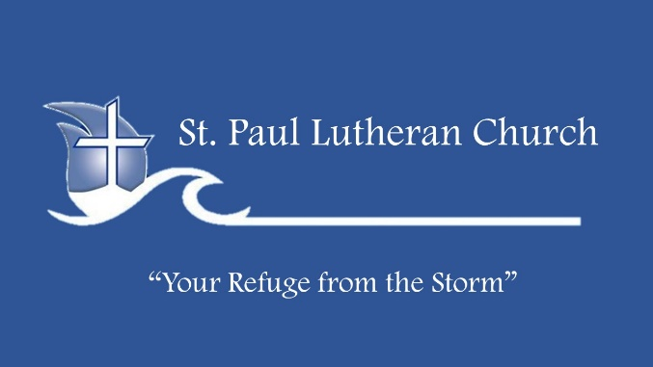
Life Group Bible Study
“Why On Earth Am I On Earth?”
You’re On Earth to Fight a Fight

January 8, 2023

ICE BREAKERS
1) After you put away the Christmas decorations, how many more things did you find still on display?

DISCUSSION:
Matthew 16:13-23 NLT When Jesus came to the region of Caesarea Philippi, He asked His disciples, "Who do people say that the Son of Man is?" 14 "Well," they replied, "some say John the Baptist, some say Elijah, and others say Jeremiah or one of the other prophets." 15 Then He asked them, "But who do you say I am?" 16 Simon Peter answered, "You are the Messiah, the Son of the living God." 17 Jesus replied, "You are blessed, Simon son of John, because My Father in heaven has revealed this to you. You did not learn this from any human being. 18 Now I say to you that you are Peter (which means 'rock'), and upon this rock I will build My church, and all the powers of hell will not conquer it. 19 And I will give you the keys of the Kingdom of Heaven. Whatever you forbid on earth will be forbidden in heaven, and whatever you permit on earth will be permitted in heaven." 20 Then He sternly warned the disciples not to tell anyone that He was the Messiah. 21 From then on Jesus began to tell His disciples plainly that it was necessary for Him to go to Jerusalem, and that He would suffer many terrible things at the hands of the elders, the leading priests, and the teachers of religious law. He would be killed, but on the third day He would be raised from the dead. 22 But Peter took Him aside and began to reprimand Him for saying such things. "Heaven forbid, Lord," he said. "This will never happen to You!" 23 Jesus turned to Peter and said, "Get away from Me, Satan! You are a dangerous trap to Me. You are seeing things merely from a human point of view, not from God's."

In Matthew 16:13-23, Peter’s confession of the identity of Jesus is followed by Peter being used by Satan to attempt to dissuade Jesus. In your own Christian life, describe how you may have been in this type of situation and what occurred. How do you think being around like minded believers (LifeGroups) can help you in these types of situations?

Study 1 Peter 4:12-19 and 1 Peter 5:6-11. How do these passages impact you and your life?

1 Peter 4:12-19 NLT Dear friends, don't be surprised at the fiery trials you are going through, as if something strange were happening to you. 13 Instead, be very glad—for these trials make you partners with Christ in His suffering, so that you will have the wonderful joy of seeing His glory when it is revealed to all the world. 14 So be happy when you are insulted for being a Christian, for then the glorious Spirit of God rests upon you. [On their part He is blasphemed, but on your part He is glorified.] 15 If you suffer, however, it must not be for murder, stealing, making trouble, or prying into other people's affairs. 16 But it is no shame to suffer for being a Christian. Praise God for the privilege of being called by His name! 17 For the time has come for judgment, and it must begin with God's household. And if judgment begins with us, what terrible fate awaits those who have never obeyed God's Good News? 18 And also, "If the righteous are barely saved, what will happen to godless sinners?" 19 So if you are suffering in a manner that pleases God, keep on doing what is right, and trust your lives to the God who created you, for He will never fail you.
1 Peter 5:6-11 NLT So humble yourselves under the mighty power of God, and at the right time He will lift you up in honor. 7 Give all your worries and cares to God, for He cares about you. 8 Stay alert! Watch out for your great enemy, the devil. He prowls around like a roaring lion, looking for someone to devour. 9 Stand firm against him, and be strong in your faith. Remember that your Christian brothers and sisters all over the world are going through the same kind of suffering you are. 10 In His kindness God called you to share in His eternal glory by means of Christ Jesus. So after you have suffered a little while, He will restore, support, and strengthen you, and He will place you on a firm foundation. 11 All power to Him forever! Amen.

INTENTIONAL INTIMACY
Now that we are into the New Year, how consistently have you been in your Bible reading and intentionally spending time with Jesus? Do you find that following a reading plan helps? Why or why not?

TOTAL SURRENDER
In 2 Corinthians 10:3-7, Paul talks about the type of warfare that we are involved in. How does TOTAL SURRENDER “play” into this concept? How do you think it impacts our lives when we hold back some of our time, treasure, and talent from Jesus?

EXPERIENCE MORE
Do you know that Christians face persecution around the world? Can you name some of the countries? Have you ever been persecuted in some fashion for your Christian beliefs? Describe what happened and how you reacted to the situation. What lesson(s) did you learn?

LOVE LIKE JESUS LOVES
When people are in desperate or difficult situations, they often ask, “Why is there so much evil, suffering, and pain in this world?” How have you answered this question in the past? How do you think we can share the love of Christ with them in their situation?

