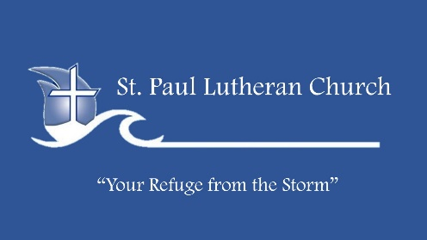
I Was Married by a Judge.
I should have asked for a Jury!
A Series on Marriage – CLEAVE
February 12, 2023

Life Group Discussion Guide
Our Study Guide is a great resource to help you direct your time with the Lord during the week and with your group. You can find the Study Guide each week at: www.stpaulkodiak.org.
Enjoy your time and let God lead you!
KICKING IT OFF:
1. Who is your biblical hero? Why?
2. What would your best friend or spouse say is your biggest quirk?
KEY IDEA:
Marriage is an illustration of the relationship between Christ and the Church.
MEMORY VERSE:
For this reason a man shall leave his father and mother, and cleave to his wife; and they shall become one flesh (Genesis 2:24).
GROUP DISCUSSION:
Describe a time where you have experienced true intimacy with the Lord.
1. What have you learned or what insight has God given you this week as you’ve spent time with Him through your daily Bible reading and in prayer? (What has God been teaching you?)
2. What was the most impactful thing you heard from your Life Group last week or the message from the weekend? Why do you think it made such an impact on you?
3. What do you think it means for a man to ‘cleave’ to his wife as instructed in Genesis 2:24-25? Describe the conflict you have seen occur when people don’t ‘leave’ their former family and ‘cleave’ to their spouse. How do you think this relates to believers who don’t ‘leave’ their old lifestyle when they commit their lives to God?
LOVE LIKE JESUS:
Hosea loved Gomer no matter what. How do you think this is an illustration of how God loves us? Who’s your Gomer?
INTENTIONAL INTIMACY:
Who in your life has been most instrumental in helping you draw closer to God and why? What practice or habit in your life has most helped you draw closer to God? Why? In what ways does or should your relationship with God resemble a marriage relationship?
FULLY SURRENDERED:
How meaningful do you think wedding vows are meant to be? How do you think that has changed over the years? What impact do you think they should have on people and their marriages? Read Ecclesiastes 5:4-5 and reflect on how your commitment to God resembles a marriage vow.
Ecclesiastes 5:4-5 NLT When you make a promise to God, don't delay in following through, for God takes no pleasure in fools. Keep all the promises you make to Him. 5 It is better to say nothing than to make a promise and not keep it.
EXPERIENCE MORE:
As we continue on the topic of marriage and our relationship with Christ, what are some areas you would like to focus on in the coming weeks to improve in these areas?

