Devotionals: FaithWalk

Date: April 9, 2023
Text: Psalm 118:1-2,14-24; Matt. 28:1-20
Belong
During the week of Passover that led to Good Friday, Jesus faced situations so grave that we can’t possibly imagine the weight that must have been pressing down on him. He faced crowds that wanted him dead, friends that denied they knew him, he endured beatings, people spitting on him, he carried the cross to his own execution and willingly laid his life down for us. Yet, in the midst of his crucifixion, he wasn’t focused on his own agony, but on the people who were crucifying him and asked God to “forgive them for they know not what they do.”
This week’s text focuses on Jesus’ resurrection, giving us reassur- ance of his presence and bringing hope to our lives that will help us overcome our fears that can overwhelm and make us feel so weighed down we hardly seem able to move. Jesus urges us to fo- cus on him so that we may, in a sense, achieve “zero gravity.” This allows us to let go of the fears that weigh us down and become an active part of bringing his good news to others.
Prayer… Heavenly Father, as we go about our daily lives we can become so weighed down and so focused on the gravity of life that we hardly seem able to move. We open our hearts to you today so that we may learn how to overcome that weight and use the freedom we gain to help ourselves and others experience you more deeply. Amen.

Become
Read Psalm 118:1-2, 14-24. What is your initial im-pression of this Psalm? What comes to mind when you think of the cornerstone? Some scholars believe that Psalm 118 was written for the dedication of the restored walls of Jerusalem in 444 B.C., which signaled a time of national restoration after many years of captivity. The cornerstone is the stone that anchors the city wall and is the reference or focal point for constructing the entire struc- ture. This cornerstone was rejected by the builders yet became the foundation for the entire wall. This parallels Israel’s journey of being rejected but being used by God as the cornerstone of God’s plan for salvation. The Israelites recognized what God had done for them and were moved to cry out, “This is the day that the Lord has made; let us rejoice and be glad in it.”
•What can we do to rejoice and be glad in each day when we are feel- ing the weight from the daily pressures of life?
Read Matthew 28:1-20. This text is Matthew’s account of Jesus’ resurrection.
- What comes to mind when you read verse 18?

Jesus’ words “All authority in heaven and on earth has been given to me” establishes him as the cornerstone of the lives of the people that were following him 2000 years ago as well as our lives today. He goes on to instruct his followers to go and make disciples of all nations and teach them his commandments. Known as “the Great Commission,” Jesus invited his disciples to join him and become part of his kingdom on earth.
- How do you think the Great Commission applies to us today?
Jesus’ command recorded in John 15:12 and the words from 1 John 4:18 allow us to understand his ultimate act of love by going to the cross. Easter is the time for us to not only remember that he laid down his life for us but also his commission which calls us to reach out to each other with God’s love. Jesus reassures us that by following his command to love others as he has loved us, we will be able to release the fears that weigh us down and be able to achieve “zero gravity” in the midst of our daily lives.
- How do you think love can drive out our fears? What does it mean to you to hear Jesus’ words in Matthew 28:20?
Believe
We all face times where life seems to be weighing us down so much that we are hardly able to move. Jesus knew very well those pressures and reassured with his words to “come to me all who are weary and burdened and I will give you rest.” Those words would have been true for his disciples after his crucifixion. They must have been filled with emotions ranging from sadness to disbelief to joy when they heard Jesus telling them to come to him. They knew he had died, yet when they heard his request to come they went.
1 John 4:16b gives us a glimpse of how we can find God in the midst of our daily lives. Jesus is reassuring us that as we are able to connect to the love God has planted deeply within us, we will be able to turn that love into action and it’s within those acts of love where we are able to continue his great commission to go and make disciples of all nations. Others will begin to sense and pos- sibly see God working within us through our acts of love and that may help them achieve what we already know, “zero gravity.”
Prayer... Lord God, thank you that we can find rest in you from the things that are weighing us down. Thank you for trusting us to continue your commission of teaching others about you. Help us connect to the deep love you’ve planted within us and show us how we can use it to help others find you. Amen.

Devotionals: DailyWalk on the Rock
Date: April 9, 2023
Text: Psalm 118:1-2,14-24; Matt. 28:1-20
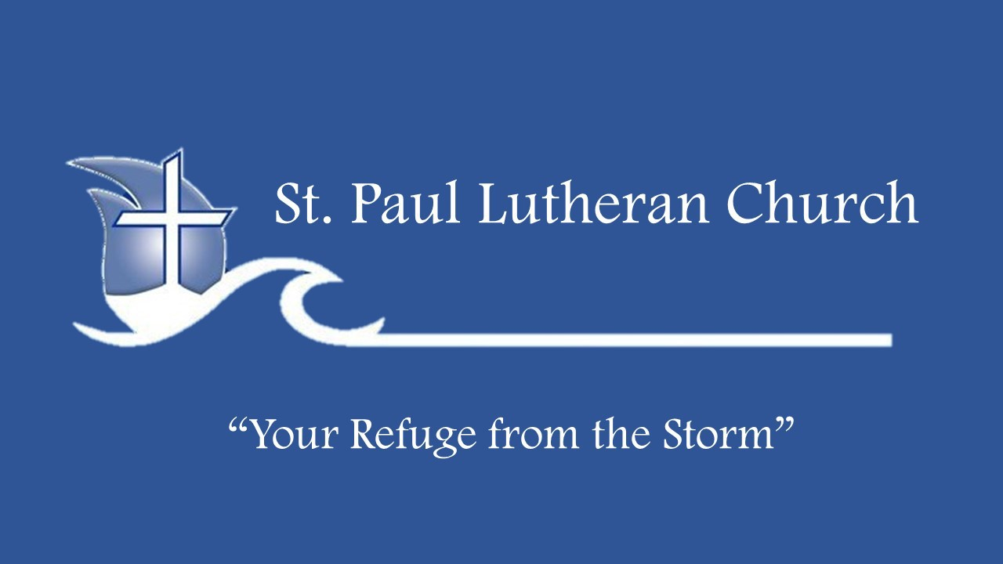

Day 1: Monday, April 10, 2023—“Because I Live” Jesus told his disciples, “Because I live, you also will live” (John 14:19). Is this promise just for eternity, or does it also have rel- evance for your life today? As you ponder this, read Luke 24:32,45 and Ephesians 1:17-23, praying the Spirit. will enable you to experience the wonder of the resurrection with new, faith-filled eyes. Read Matthew 28:1-10; imagine you are with the women as they approach the tomb on Easter morning. Pray you will experience the resurrection personally as you meet the angel and then actually behold your living Lord. Worship Jesus (28:9).

Day 2: Tuesday, April 11, 2023—Zero Gravity
For weeks we have pondered aspects of our human condition that disconnect us from God’s presence in and purpose for our lives. Jesus invites us to leave our sin, shame, and self-focused desires at the foot of the cross; he offers us instead the freedom, joy, and glory of real, resurrection life in him. Consider what this means as you read John 10:10; 11:25-26; 17:3 and Romans 6:18; 8:1-2. Now read Matthew 28:1-10, remembering that the women went to the tomb planning on anointing a dead body; they left worship- ing the living Savior and with the commission to “go and tell” (28:9-10). Talk to Jesus about what the resurrection means for you, today.

Day 3: Wednesday, April 12, 2023—“Do Not Be Afraid”
Read Matthew 28:1-10, noticing the references to fear and the invitation to abandon fear [“do not be afraid”]. What enabled the movement from fear to faith? Consider that there was no assur- ance of temporal happiness or an easy life; in fact, Jesus had told his followers they would have troubles (John 12:23-26; 15:18-21; 16:33; 17:13-14). The invitation was not to ease but, rather, to live in the reality that Jesus is who he says he is, and that all of God’s promises are true (see 2 Corinthians 1:20). This invitation is also for us. Do you live in the joy of knowing that Jesus is alive and that his life makes all the difference, for today and forever? Ask Jesus to turn your fear to faith.

Day 4: Thursday, April 13, 2023—The Gate (Door) to God’s Presence
The synergy of Scripture is amazing; from Genesis to Revelation, it is God’s story. Read Luke 13:24 and John 10:7,9; 14:6. Con- sider that Jesus himself is the gate (or door) to life with God, today and forever. Now read Psalm 118:1-2,14-24. Did you notice the request in 118:19? Who is the Psalmist’s salvation (118:20-21)? And Jesus is not only the door or gate, he is also the cornerstone (Psalm 118:22; Isaiah 28:16; Ephesians 2:19-22; 1 Peter 2:6-7). Read Psalm 118:1-2,14-gain, this time aloud; notice the glad-ness and joy; make this your prayer and praise.

Day 5: Friday, April 14, 2023—Of First Importance! Read Psalm 118:1-2,14-24 and Matthew 28:1-10. Ponder Psalm 118:24; are you experiencing this joy and sense of gladness? Are you concerned that others know this joy? Have you embraced the truth and the importance of the resurrection? Read 1 Corinthians 15:3-8,20-22 and 1 Peter 1:3-5. Do you know the “living hope” of which Peter speaks? Walk out of the tomb with Jesus into real, fearless, full, joyful life in his name. Share the joy, hope, and gladness of the resurrection with others. Pray the Holy Spirit will lead you to others who long to know the
good news of the resurrection and its promise for eternity and its promise for real life today (John 3:16; 8:32,36; 10:10; 14:19).

Day 6: Saturday, April 15, 2023—Fear or Worship? Choose Worship!
Read Matthew 28:1-20, noticing the references to fear and worship. How might God use our worship to dispel our fear (remember: worship is recognizing the immeasurable worth of the One worshiped)? Psalm 22:3 KJV reads: “Thou art holy, O Thou, that inhabits the praises of Israel.” Notice the movement toward the presence of God as you read Psalm 100:1-2,4; now ponder Hebrews 13:15. Meditate on these thoughts and sing or pray Newton’s lyrics: “’Twas grace that taught my heart to fear, and grace my fears relieved; how precious did that grace appear the hour I first believed!” and then, “…we’ve no less days to sing God’s praise than when we’d first begun.”

Day 7: Sunday, April 16, 2023—“Come and See”; “Go and Tell”
Read Matthew 28:1-20, noticing the urgency of the invitations to “come and see” and “go and tell.” Consider that, as we tell others of our experience with Jesus, our own faith is affirmed. Is this truth also seen in Psalm 118:1-2,14-24? We are told to “make disciples” (Matthew 28:18-20); can we do this apart from being in relationship with others? And notice that we do not go forth in our own strength. We go with Jesus’ authority and abiding presence and in the power of the Spirit (Matthew 28:18-20; Acts 1:8). Read John 21:15-17 and Romans 10:8-15. Pray your life, compassion, love, joy, and words will point others to Jesus and create in them the desire to be disciples.

